$$\frac{dy}{dx}=f(t, y)$$

$$y_{k+1}= y_{k}+hf(t_{k+1}, y_{k+1})$$

$$f(t_{k+1}, y_{k+1})$$

$$y_{k+1}^{[0]}=y_{k}, y_{k+1}^{[i+1]}=y_{k}+hf(t_{k+1}, y_{k+1}^{[i]})$$

$$\frac{dy}{dx}=f\left(t, y\right) t_{n} t_{n+1}=t_{n}+h$$

$$y\left(t_{n+1}\right)-y\left(t_{n}\right)=\int_{t_{n}}^{t_{n+1}}{f(t, y(t))dt}$$

$$y\left(t_{n+1}\right)-y(t_{n})≈hf\left(t_{n+1}, y(t_{n+1})\right)$$

Method of Lines

The method of lines was introduced to take the place of spatial differential operator by an approximation.

We have to choose the finite difference discretization method that we have already employed for the Poisson equation.

We approximate the differential operator delta by

$$∆_{h}:G_{0}\left({Ω }_{h}\right)→G_{0}\left({Ω }_{h}\right)$$

Defined as

$$∆_{h}v\left(x\right)=$$

$$\frac{v\left(x_{1}+h{,x}_{2}\right)+v\left(x_{1}-h{,x}_{2}\right)+v\left(x_{1},x_{2}+h\right)+v\left(x_{1},x_{2}-h\right)-4v(x)}{h^{2}}$$

For all x belongs to (Omega)h and extended by

$$∆_{h}v\left(x\right)=0$$

Replacing u, g, and uo by

$$u_{h}\left(t\right) :=\hat{u}\left(t\right)|_{Ω_{h}}, g_{h}\left(t\right) :=\hat{g}\left(t\right)|_{Ω_{h }} ,$$

$$u_{0}\left(t\right) :=\hat{u_{0}}\left(t\right)|_{Ω_{h}} for all t ∈ R ≥0$$

We obtain the approximation

$u_{h}(0)=u_{0,h}$ ${{u^{'}}_{h}\left(t\right)=g_{h}\left(t\right)+ ∆}_{h}u_{h}(t)$

$$for all t∈ R ≥0$$

And the above equation is an ordinary differential equation in the finite dimensional space.

$$f: R≥0 ×G_{0}\left(Ω_{h}\right)→ G_{0}\left(Ω_{h}\right)$$

We can write (3.3) in the standard form

$u_{h}(0)=u_{0,h}$ ${u^{'}}_{h}(t)=f(t,u_{h}(t))$

$$for all t∈ R≥0 (3.5)$$

## Lemma 3.1 (Unique Solution)

As the ordinary differential equation has unique solution .i.e.

**Proof -** Since Go(Omegah) is finite-dimensional, the mapping Omegah is continuous, i.e., there is a constant Co such that

${∥∆_{h}y_{h}∥}_{∞}≤C_{∆}∥y_{h}∥_{∞}$ $for all y_{h}ϵ G_{0}(Ω_{h})$

We find

$${∥f\left(t, y_{h}\right)-f\left(t, z_{h}\right)∥}_{∞}= {∥∆_{h}y_{h}- ∆_{h}z_{h}∥}_{∞}= {∥∆_{h}{(y}_{h}- z_{h})∥}_{∞ }≤C_{∆}∥y_{h}- z_{h}∥$$

$$for all y_{h}, z_{h} ϵ G_{0}(Ω_{h})$$

The existence of C is the result that h is a linear mapping between finite-dimensional spaces. This approach doesn’t provide any information regarding the behavior of the Lipschitz constant. In the case of our model problem, we can fortunately calculate all eigenvalues and eigenvectors of h, and this gives us good insight into the behavior of the system. Before we consider the two-dimensional problem, we first take a look at the approximation of the one-dimensional Poisson equation.

$${(0, 1)}_{h}≔\left\{ih :i ∈\left[1:N\right]\right\},$$

$${[0, 1]}_{h}≔\left\{ih :i ∈\left[0:N+1\right]\right\},$$

And the space

C:\Users\Waris\Desktop\late1.png

Of grid functions. central difference approximation of the second derivative is given by

C:\Users\Waris\Desktop\late1.png

## Lemma 3.2 (One-dimensional eigenvectors)

We Define

C:\Users\Waris\Desktop\late1.png

C:\Users\Waris\Desktop\late1.png

Then we have

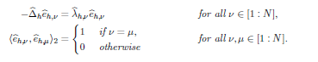

**Proof**. For the first result, we make use of the trigonometric identities.

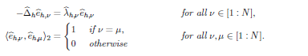

Then we have

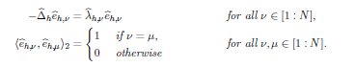

Proof. For the first result, we make use of trigonometric identities

C:\Users\Waris\Desktop\late1.png

Proof. For the first result, we make use of the trigonometric identities

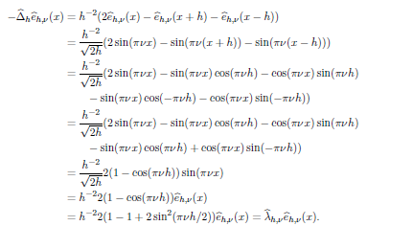

For the second result, we apply the trigonometric identity

C:\Users\Waris\Desktop\late1.png

Let v, u belongs to [1 : N]. We have

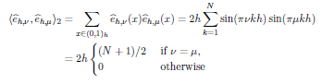

C:\Users\Waris\Desktop\late1.png

We have found a complete orthonormal basis of Go([0; 1]h) consisting of eigenvectors in the one dimensional case. Since the two-dimensional case is closely related, our results carry over directly.

## Lemma 3.3 (Eigenvalues)

We define

C:\Users\Waris\Desktop\late1.png